|  |
| --- |
| *# importing lib.* **import** numpy **as** np **import** pandas **as** pd **import** matplotlib.pyplot **as** plt **import** seaborn **as** sns |

In [1]:

|  |  |
| --- | --- |
| df **=** pd**.**read_csv('mymoviedb.csv', lineterminator**=**'\n') df**.**head() |  |
| **Release_Date Title Overview Popularity Vote_Count** | **Vote_Average Original_** |

In [2]:

Out[2]:

Peter Parker

Spideris unmasked Man:

**0** 2021-12-15 and no 5083.954 8940 8.3

No Way longer able

Home

to...

|  |  |  |  |  |  |  |
| --- | --- | --- | --- | --- | --- | --- |
| **1** | 2022-03-01 | The  Batman | In his second year of fighting crime, Batman u... | 3827.658 | 1151 | 8.1 |
| **2** | 2022-02-25 | No Exit | Stranded at a rest stop in the mountains durin... | 2618.087 | 122 | 6.3 |
| **3** | 2021-11-24 | Encanto | The tale of an  extraordinary family, the Madri... | 2402.201 | 5076 | 7.7 |
| **4** | 2021-12-22 | The  King's  Man | As a  collection of history's worst tyrants and... | 1895.511 | 1793 | 7.0 |

|  |
| --- |
| *# viewing dataset info* df**.**info() |

In [3]:

<class 'pandas.core.frame.DataFrame'>

RangeIndex: 9827 entries, 0 to 9826 Data columns (total 9 columns):

# Column Non-Null Count Dtype --- ------ -------------- ----- 0 Release_Date 9827 non-null object

1. Title 9827 non-null object
2. Overview 9827 non-null object
3. Popularity 9827 non-null float64
4. Vote_Count 9827 non-null int64
5. Vote_Average 9827 non-null float64
6. Original_Language 9827 non-null object
7. Genre 9827 non-null object 8 Poster_Url 9827 non-null object dtypes: float64(2), int64(1), object(6) memory usage: 691.1+ KB

• looks like our dataset has no NaNs! • Overview, Original_Language and Poster-Url wouldn't be so useful during analysis • Release_Date column needs to be casted into date time and to extract only the year value

In [8]: *# exploring genres column* df['Genre']**.**head()

Out[8]: 0 Action, Adventure, Science Fiction 1 Crime, Mystery, Thriller

1. Thriller
2. Animation, Comedy, Family, Fantasy
3. Action, Adventure, Thriller, War

Name: Genre, dtype: object

* genres are saperated by commas followed by whitespaces.

In [11]: *# check for duplicated rows* df**.**duplicated()**.**sum()

Out[11]: 0

* our dataset has no duplicated rows either.

In [15]: *# exploring summary statistics* df**.**describe()

Out[15]: **Popularity Vote_Count Vote_Average**

**count** 9827.000000 9827.000000 9827.000000

|  |  |  |  |  |
| --- | --- | --- | --- | --- |
| **mean** | 40.326088 | 1392.805536 |  | 6.439534 |
| **std** | 108.873998 | 2611.206907 |  | 1.129759 |
| **min** | 13.354000 | 0.000000 |  | 0.000000 |
| **25%** | 16.128500 | 146.000000 |  | 5.900000 |
| **50%** | 21.199000 | 444.000000 |  | 6.500000 |
| **75%** | 35.191500 | 1376.000000 |  | 7.100000 |
| **max** | 5083.954000 | 31077.000000 |  | 10.000000 |

In [ ]: • Exploration Summary

* we have a dataframe consisting of 9827 rows **and** 9 columns**.**
* our dataset looks a bit tidy **with** no NaNs nor duplicated values**.**
* Release_Date column needs to be casted into date time **and** to extract only the
* Overview, Original_Languege **and** Poster**-**Url wouldn't be so useful during analys
* there **is** noticable outliers **in** Popularity column
* Vote_Average bettter be categorised **for** proper analysis**.**
* Genre column has comma saperated values **and** white spaces that needs to be hand

In [18]: *# Data Cleaning*

Casting Release_Date column and extracing year values

In [21]: df**.**head()

Out[21]: **Release_Date Title Overview Popularity Vote_Count Vote_Average Original_**

Peter Parker

Spideris unmasked Man:

**0** 2021-12-15 and no 5083.954 8940 8.3

No Way longer able

Home

to...

|  |  |  |  |  |  |  |
| --- | --- | --- | --- | --- | --- | --- |
| **1** | 2022-03-01 | The  Batman | In his second year of fighting crime, Batman u... | 3827.658 | 1151 | 8.1 |
| **2** | 2022-02-25 | No Exit | Stranded at a rest stop in the mountains durin... | 2618.087 | 122 | 6.3 |
| **3** | 2021-11-24 | Encanto | The tale of an  extraordinary family, the Madri... | 2402.201 | 5076 | 7.7 |
| **4** | 2021-12-22 | The  King's  Man | As a  collection of history's worst tyrants and... | 1895.511 | 1793 | 7.0 |

|  |
| --- |
| *# casting column a*  df['Release_Date'] **=** pd**.**to_datetime(df['Release_Date'])  *# confirming changes*  print(df['Release_Date']**.**dtypes) |

In [23]:

datetime64[ns]

|  |
| --- |
| df['Release_Date'] **=** df['Release_Date']**.**dt**.**year df['Release_Date']**.**dtypes |

In [25]:

Out[25]: dtype('int32')

|  |
| --- |
| df**.**info() |

In [27]:

<class 'pandas.core.frame.DataFrame'>

RangeIndex: 9827 entries, 0 to 9826 Data columns (total 9 columns):

# Column Non-Null Count Dtype --- ------ -------------- ----- 0 Release_Date 9827 non-null int32

1. Title 9827 non-null object
2. Overview 9827 non-null object
3. Popularity 9827 non-null float64
4. Vote_Count 9827 non-null int64
5. Vote_Average 9827 non-null float64
6. Original_Language 9827 non-null object
7. Genre 9827 non-null object 8 Poster_Url 9827 non-null object dtypes: float64(2), int32(1), int64(1), object(5) memory usage: 652.7+ KB

|  |  |  |  |  |  |
| --- | --- | --- | --- | --- | --- |
| df**.**head() |  |  |  |  |  |
| **Release_Date** | **Title** | **Overview** | **Popularity** | **Vote_Count** | **Vote_Average Original_** |

In [29]:

Out[29]:

Peter Parker

Spideris unmasked Man:

**0** 2021 and no 5083.954 8940 8.3

No Way longer able

Home to...

|  |  |  |  |  |  |  |
| --- | --- | --- | --- | --- | --- | --- |
| **1** | 2022 | The  Batman | In his second year of fighting crime, Batman u... | 3827.658 | 1151 | 8.1 |
| **2** | 2022 | No Exit | Stranded at a rest stop in the mountains durin... | 2618.087 | 122 | 6.3 |
| **3** | 2021 | Encanto | The tale of an  extraordinary family, the Madri... | 2402.201 | 5076 | 7.7 |
| **4** | 2021 | The  King's  Man | As a  collection of history's worst tyrants and... | 1895.511 | 1793 | 7.0 |

**Dropping Overview, Original_Languege and Poster-Url**

In [32]: *# making list of column to be dropped*

cols **=** ['Overview', 'Original_Language', 'Poster_Url']

*# dropping columns and confirming changes* df**.**drop(cols, axis **=** 1, inplace **=** **True**) df**.**columns

Out[32]: Index(['Release_Date', 'Title', 'Popularity', 'Vote_Count', 'Vote_Average',

'Genre'], dtype='object')

|  |
| --- |
| df**.**head() |

In [34]:

Out[34]: **Release_Date Title Popularity Vote_Count Vote_Average Genre**

Spider- Action,

**0** 2021 Man: No 5083.954 8940 8.3 Adventure, Way Home Science Fiction

|  |  |  |  |  |  |  |
| --- | --- | --- | --- | --- | --- | --- |
| **1** | 2022 | The Batman | 3827.658 | 1151 | 8.1 | Crime, Mystery, Thriller |
| **2** | 2022 | No Exit | 2618.087 | 122 | 6.3 | Thriller |
| **3** | 2021 | Encanto | 2402.201 | 5076 | 7.7 | Animation,  Comedy,  Family, Fantasy |
| **4** | 2021 | The King's  Man | 1895.511 | 1793 | 7.0 | Action,  Adventure, Thriller, War |

**categorizing Vote_Average column**

We would cut the Vote_Average values and make 4 categories: popular average below_avg not_popular to describe it more using catigorize_col() function

provided above.

|  |
| --- |
| **def** catigorize_col (df, col, labels):  """  catigorizes a certain column based on its quartiles Args:  (df) df - dataframe we are proccesing  (col) str - to be catigorized column's name (labels) list - list of labels from min to max  Returns:  (df) df - dataframe with the categorized col  """    *# setting the edges to cut the column accordingly*  edges **=** [df[col]**.**describe()['min'], df[col]**.**describe()['25%'], df[col]**.**describe()['50%'], df[col]**.**describe()['75%'], df[col]**.**describe()['max']] |

In [37]:

df[col] **=** pd**.**cut(df[col], edges, labels **=** labels, duplicates**=**'drop') **return** df

|  |
| --- |
| *# define labels for edges*  labels **=** ['not_popular', 'below_avg', 'average', 'popular']  *# categorize column based on labels and edges* catigorize_col(df, 'Vote_Average', labels)  *# confirming changes* df['Vote_Average']**.**unique() |

In [39]:

Out[39]: ['popular', 'below_avg', 'average', 'not_popular', NaN]

Categories (4, object): ['not_popular' < 'below_avg' < 'average' < 'popular']

In [41]: df**.**head()

Out[41]: **Release_Date Title Popularity Vote_Count Vote_Average Genre**

|  |  |  |  |  |  |  |
| --- | --- | --- | --- | --- | --- | --- |
| **0** | 2021 | Spider-  Man: No Way Home | 5083.954 | 8940 | popular | Action,  Adventure, Science Fiction |
| **1** | | 2022 | The Batman | 3827.658 | 1151 | popular | Crime, Mystery, Thriller | |
| **2** | | 2022 | No Exit | 2618.087 | 122 | below_avg | Thriller | |
| **3** | | 2021 | Encanto | 2402.201 | 5076 | popular | Animation,  Comedy,  Family, Fantasy | |
| **4** | | 2021 | The King's  Man | 1895.511 | 1793 | average | Action,  Adventure, Thriller, War | |

In [43]: *# exploring column* df['Vote_Average']**.**value_counts()

|  |  |
| --- | --- |
| Out[43]: | Vote_Average not_popular 2467 popular 2450 average 2412 below_avg 2398  Name: count, dtype: int64 |

In [45]: *# dropping NaNs* df**.**dropna(inplace **=** **True**)

*# confirming* df**.**isna()**.**sum()

|  |  |
| --- | --- |
| Out[45]: | Release_Date 0  Title 0  Popularity 0  Vote_Count 0  Vote_Average 0 Genre 0 dtype: int64 |

In [47]: df**.**head()

Out[47]: **Release_Date Title Popularity Vote_Count Vote_Average Genre**

|  |  |  |  |  |  |  |
| --- | --- | --- | --- | --- | --- | --- |
| **0** | 2021 | Spider-  Man: No Way Home | 5083.954 | 8940 | popular | Action,  Adventure, Science Fiction |
| **1** | | 2022 | The Batman | 3827.658 | 1151 | popular | Crime, Mystery, Thriller | |
| **2** | | 2022 | No Exit | 2618.087 | 122 | below_avg | Thriller | |
| **3** | | 2021 | Encanto | 2402.201 | 5076 | popular | Animation,  Comedy,  Family, Fantasy | |
| **4** | | 2021 | The King's  Man | 1895.511 | 1793 | average | Action,  Adventure, Thriller, War | |

**we'd split genres into a list and then explode our dataframe to have only one genre per row for ezch movie**

In [52]: *# split the strings into lists* df['Genre'] **=** df['Genre']**.**str**.**split(', ')

*# explode the lists*

df **=** df**.**explode('Genre')**.**reset_index(drop**=True**) df**.**head()

Out[52]: **Release_Date Title Popularity Vote_Count Vote_Average Genre**

Spider-Man: No

**0** 2021 5083.954 8940 popular Action

Way Home

|  |  |  |  |  |  |  |  |
| --- | --- | --- | --- | --- | --- | --- | --- |
| **1** | 2021 | Spider-Man: No Way Home | 5083.954 |  | 8940 | popular | Adventure |
| **2** | 2021 | Spider-Man: No Way Home | 5083.954 |  | 8940 | popular | Science Fiction |
| **3** | 2022 | The Batman | 3827.658 |  | 1151 | popular | Crime |
| **4** | 2022 | The Batman | 3827.658 |  | 1151 | popular | Mystery |

|  |
| --- |
| *# casting column into category*  df['Genre'] **=** df['Genre']**.**astype('category')  *# confirming changes* df['Genre']**.**dtypes |

In [55]:

Out[55]: CategoricalDtype(categories=['Action', 'Adventure', 'Animation', 'Comedy', 'Cri me',

'Documentary', 'Drama', 'Family', 'Fantasy', 'History',

'Horror', 'Music', 'Mystery', 'Romance', 'Science Fiction',

'TV Movie', 'Thriller', 'War', 'Western'],

, ordered=False, categories_dtype=object)

|  |
| --- |
| df**.**info() |

In [57]:

<class 'pandas.core.frame.DataFrame'>

RangeIndex: 25552 entries, 0 to 25551 Data columns (total 6 columns):

# Column Non-Null Count Dtype --- ------ -------------- ----- 0 Release_Date 25552 non-null int32

1. Title 25552 non-null object
2. Popularity 25552 non-null float64
3. Vote_Count 25552 non-null int64
4. Vote_Average 25552 non-null category 5 Genre 25552 non-null category

dtypes: category(2), float64(1), int32(1), int64(1), object(1) memory usage: 749.6+ KB

In [59]: df**.**nunique()

Out[59]: Release_Date 100 Title 9415

Popularity 8088

Vote_Count 3265

Vote_Average 4 Genre 19 dtype: int64

Now that our dataset is clean and tidy, we are left with a total of 6 columns and 25551 rows to dig into during our analysis

**Data Visualization**

here, we'd use Matplotlib and seaborn for making some informative visuals to gain insights abut our data.

In [62]: *# setting up seaborn configurations* sns**.**set_style('whitegrid')

**Q1: What is the most frequent genre in the dataset?**

In [65]: *# showing stats. on genre column* df['Genre']**.**describe()

Out[65]: count 25552 unique 19 top Drama freq 3715 Name: Genre, dtype: object

|  |
| --- |
| *# visualizing genre column*  sns**.**catplot(y **=** 'Genre', data **=** df, kind **=** 'count', order **=** df['Genre']**.**value_counts()**.**index, color **=** '#4287f5') plt**.**title('genre column distribution') plt**.**show() |

In [67]:

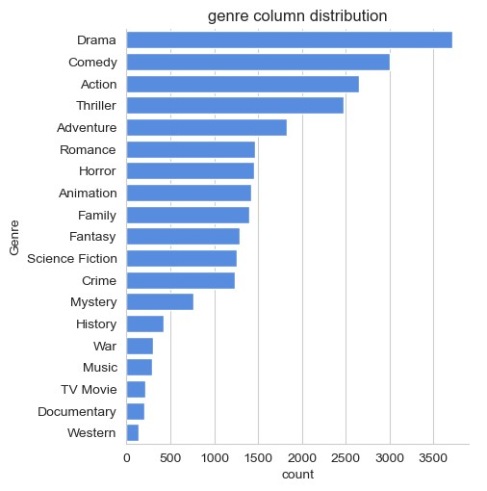

we can notice from the above visual that

Drama

genre is the most frequent genre

in our dataset and has appeared more than 14% of the times among 19 other genres.

**Q2: What** genres **has highest** votes **?**

|  |
| --- |
| *# visualizing vote_average column*  sns**.**catplot(y **=** 'Vote_Average', data **=** df, kind **=** 'count', order **=** df['Vote_Average']**.**value_counts()**.**index, color **=** '#4287f5') plt**.**title('votes destribution') plt**.**show() |

In [71]:

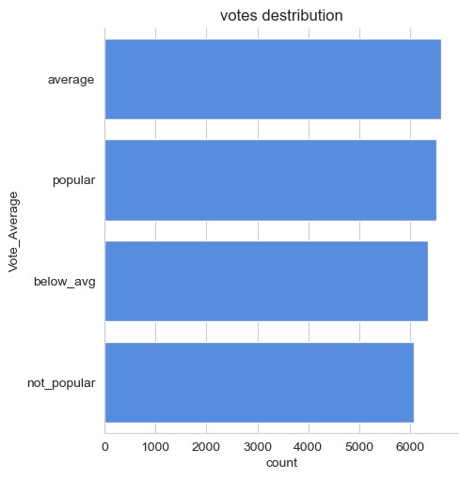

**Q3: What movie got the highest** popularity **? what's its** genre **?**

|  |
| --- |
| *# checking max popularity in dataset* df[df['Popularity'] **==** df['Popularity']**.**max()] |

In [74]:

Out[74]: **Release_Date Title Popularity Vote_Count Vote_Average Genre**

Spider-Man:

**0** 2021 5083.954 8940 popular Action No Way Home

|  |  |  |  |  |  |  |
| --- | --- | --- | --- | --- | --- | --- |
| **1** | 2021 | Spider-Man: No Way Home | 5083.954 | 8940 | popular | Adventure |
| **2** | 2021 | Spider-Man: No Way Home | 5083.954 | 8940 | popular | Science Fiction |

**Q4: What movie got the lowest popularity? what's its genre?**

|  |
| --- |
| *# checking max popularity in dataset* df[df['Popularity'] **==** df['Popularity']**.**min()] |

In [86]:

Out[86]: **Release_Date Title Popularity Vote_Count Vote_Average Genre**

The United

**25546** 2021 States vs. 13.354 152 average Music

Billie Holiday

|  |  |  |  |  |  |  |
| --- | --- | --- | --- | --- | --- | --- |
| **25547** | 2021 | The United States vs. Billie Holiday | 13.354 | 152 | average | Drama |
| **25548** | 2021 | The United States vs. Billie Holiday | 13.354 | 152 | average | History |
| **25549** | 1984 | Threads | 13.354 | 186 | popular | War |
| **25550** | 1984 | Threads | 13.354 | 186 | popular | Drama |
| **25551** | 1984 | Threads | 13.354 | 186 | popular | Science Fiction |

**Q5: Which year has the most filmmed movies?**

|  |
| --- |
| df['Release_Date']**.**hist() plt**.**title('Release_Date column distribution') plt**.**show() |

In [82]:

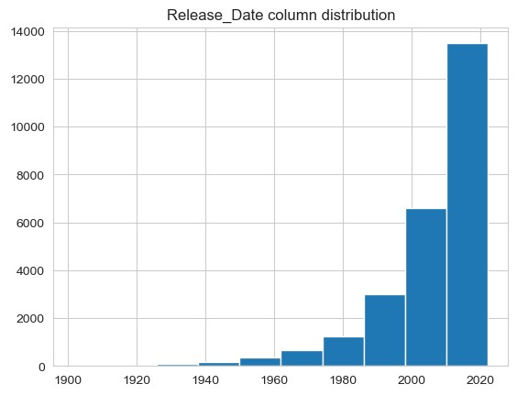

**Conclusion**

**Q1: What is the most frequent** genre **in the dataset?**

Drama genre is the most frequent genre in our dataset and has appeared more than 14% of the times among 19 other genres.

**Q2: What** genres **has highest** votes **?**

we have 25.5% of our dataset with popular vote (6520 rows). Drama again gets the highest popularity among fans by being having more than 18.5% of movies popularities.

**Q3: What movie got the highest** popularity **? what's its** genre **?**

Spider-Man: No Way Home has the highest popularity rate in our dataset and it has genres of Action , Adventure and Sience Fiction .

**Q3: What movie got the lowest** popularity **? what's its** genre **?**

The united states, thread' has the highest lowest rate in our dataset and it has genres of music , drama , 'war', 'sci-fi' and history`.

**Q4: Which year has the most filmmed movies?**

year 2020 has the highest filmming rate in our dataset.

|  |
| --- |
|  |

In [ ]: